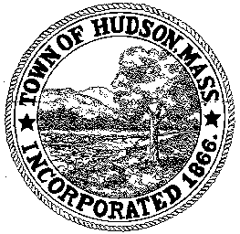

CONSERVATION COMMISSION
78 Main Street, Hudson, MA 01749
(978) 562-2020

Paul Byrne, Chairman W. Minot Wood, Vice Chairman David Esteves, Member

Terrence Joyce, Member Leif Longtine, Member Joseph Rodrigues, Member Al Tashian, Member

Meeting Agenda
July 15, 2010 7:00 P.M.

- Preliminaries
  - Open Meeting
  - Roll Call

2.0 Hearings and Appointments
2.1 DEP 190-534
Request for extension
Applicant: Riverside Estates Condominium Association
Location: 125 Chapin Road

2.2 DEP 190-
Applicant: Town of Hudson DPW
Location: Rolling Lane/Four Bridges Road/Rathburn Road/River Road/ Chapin Road and Brigham Street
Project Description: the installation of 4500’ of 8” gravity sewer lines, 7300’ of 6” force mains, 3000’ of 2’ and 3” low pressure sewer lines, the construction of a sewer pump station and the reconfiguration of 60’ of storm drains.

2.3 DEP 190-
Applicant: Elks
Location: 91 Park Street
Project Description: replacement of a collapsed corrugated metal culvert under an existing driveway.

2.4 DEP 190-
Applicant: Martin Libby
Location: 35 Worcester Avenue
Project Description: for the removal of a dead tree, replacement of an existing dock and the construction of a wall and patio

2.5 RDA 397
Applicant: Warren Cunningham/Mario Quintal
Location: 74 Bennett Street
Project Description: construction of a stonewall

3.0 General Business
3.1 Voucher 063010 $569.13
3.2 New Business
3.3 Old Business
4.0 Adjournment

